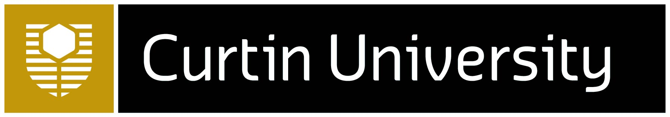­­­­­­­­­­

This project is supported by the Australia Korea Foundation grant AKF00863 (2022-2025).

For more information contact

humanities-outreach@curtin.edu.au

**When:** Monday evenings from 4.00pm – 5.30pm beginning 27 February (excluding school holidays)

**Duration**: 11 weeks

**Venue:** Curtin Bentley Campus

Free language course for high school students looking to enhance their pathway into a University degree, or for students just wanting to learn more about Korea and its dynamic culture. This course is open to students who have never formally studied Korean before, and classes include Korean cultural activities ranging from calligraphy to K-pop. Students following blended entry pathways to University are strongly encouraged to apply.

Get in quick. Places are limited.

Free Korean language training opportunities for all Y11 and Y12 high school students in Western Australia at Curtin University.

Supercharge your future. Learn Korean.

Make tomorrow better. curtin.edu.au

CRICOS Provider Code 00301J