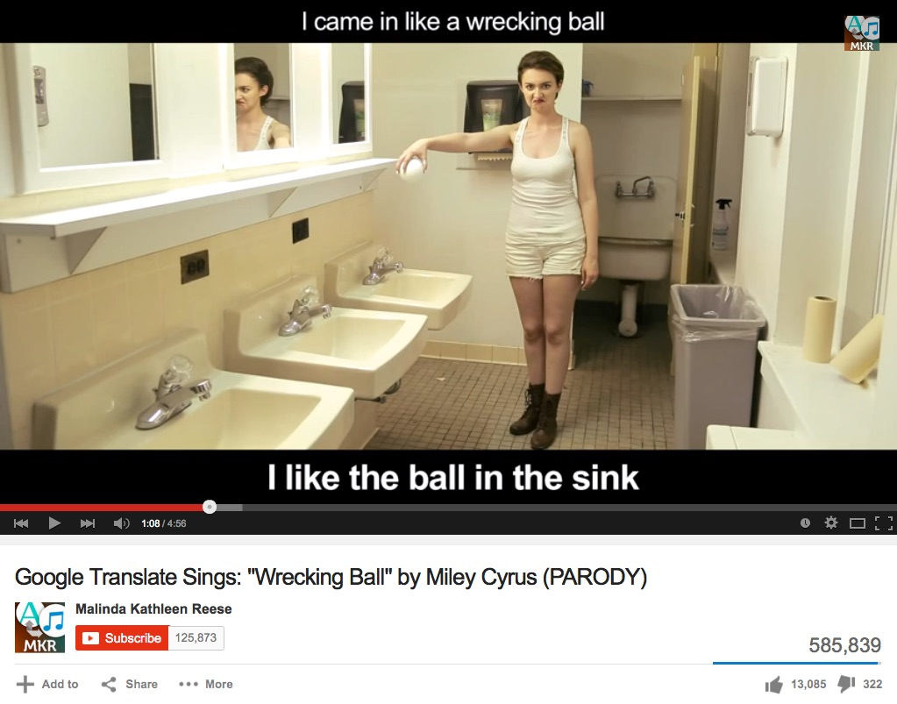
Translator Challenge
This activity will help you evaluate computer-assisted translations.

Step 1: Research
Locate and use two different online translators.
List the websites used:

1: _______________________

2: _______________________
Step 2: Try it out
Translate the following pairs of sentences on each of the two internet translation services, from English to Indonesian and then back to English:

Sentence |  | English to Indonesian (write the Indonesian below) | Translate the same sentence back to English
I’m not sure this translator is working. | Site 1
 | Site 2
I like ice cream with nuts on top. | Site 1
 | Site 2
Some people think I am nuts. | Site 1
 | Site 2
I can drink a can of ginger beer. | Site 1
 | Site 2
Can you dance the can-can? | Site 1
 | Site 2
If I get any more chocolates, I’ll get sick of them. | Site 1
 | Site 2
I once visited Indonesia on a study tour. | Site 1
 | Site 2
Let’s go out for dinner tonight. | Site 1
 | Site 2
The young guy from that band is hot! | Site 1
 | Site 2
The head of the village said not to cut down the coconut trees. | Site 1
 | Site 2
You know I don’t like eating tofu! | Site 1
 | Site 2
I love Indonesian. | Site 1
 | Site 2

Which translator did better, and why?

Highlight all of the Indonesian sentences that are informal in green and formal in yellow. What do you notice?

Step 3: Try it out

- Write a one paragraph autobiography in English – name, age, family or friends, likes, future plans.

- Choose the best translator from Step 2. Paste in your English paragraph, translate it into French.

- Translate the French into any language other than English (e.g. Arabic!).

- Translate it into Indonesian. Copy and paste the Indonesian into the table below.

- Translate it back into English. Copy and paste the English into the table.

English original | Indonesian translation (after 2 other translations) | Final English translation

Step 4: Reflection
Delete any statements that are false:

- My teacher will be able to tell easily if I use an online translator.
- Online translators do an excellent job.
- Online translators do an OK job.
- I might use an online translator to help get the gist of text.
- I’m going to double-check any work I do using an online translator.
- Online translators will save me a lot of time when doing written work.
- This was a useful activity for me.
- I am better off adapting models from class or other examples than using a translator straight away.

